……………………………………………………………….

PROPOSED TRIP FOR YOUR SCHOOL TOUR TO WESTERN UGANDA 2023

The melmarc safaris

Location; Kawanda central zone

Tel; 0751206553, 0782149654

Email;ssenkumbamicheal426@gmail.com

**TITLE: THE GREAT WESTERN TOUR**

**ROAD MAP OF THE JOURNEY AND PLAN FOR ACTIVITIES**

Expected time for departure 5:00 am

Expected time to report back 07:00pm

1 teacher per 25 heads of children will be free

**Fee300,000 Shs**

**DAY ONE**

Pupils assemble for the prayer, packing their property and sitting into the bus

Leave school via Kampala-masaka high way

* We then have our breakfast as we continue with the journey(chapatti and soda)

Stop over at Kayabwe (Equator) for photos and information about the equator. Here children will be able to stand in both Northern and Southern Hemisphere

1. Stop over at lukaya for Muchomo (to those that have pocket money)
2. View large scale rice growing in Lwera by Pastor Kakande
3. Have a view of River Katonga as we continue our journey to Masaka( here our tour guides will be passing through the economic importance of rivers to the people near them)
4. Have lunch at st marys school in kaddugala masaka city; (matooke, rice,water, chicken vegetables and greens,soda )
5. Continue to Mbarara via Mbarara- Masaka road
6. Road side view of Zebras in Lake Mburo National park
7. Visit to Igongo cultural Museum where we learn about Ankole culture,we will see all Uganda’s currencies, some of the tools that were used by the early man, take photos etc
8. View the eclipse monument which is much talked about in Ankole culture
9. Continue to Mbarara city as we enjoy Ankole the land of milk. Pupils will see the cow statue as we enter Mbarara city.
10. Mbarara city View Mbarara university of applied sciences as we leave Mbarara for ishaka .
11. Go to Kitagata hot springs in Sheema district
12. Drive back to Kasese viewing Kyamuhunga Tea estate, Bunyaruguru craters lakes, and the western lift valley as we travel. ( a stop over for a breath taking view of Queen Elizabeth National park at Kyamburu gorge
13. Have supper (rice, matooke kalo, soda, chapatti, beef, water melon cow peas, g.nuts etc) and then have accommodation in our nice hotel (Lake Munyanyange hotel in the center of queen elithabeth national park.)

**DAY 2**

1. Wake up vey early in the morning, do morning personal administration and have health break at 6:00am(milk, black tea, chapatti chips, yellow banana)
2. Take a drive through the park to kasenyi plains (basically tracing for the lion)
3. expect to see mammals such as Lions , Baffalos , wathog ,antelopes,water park Elephants and some other mating grands.
4. Boat cruise on Kazinga channel (Here we will view a large number of Hippopotamus and this is the biggest of all in Africa.(at mweya Peninsular) learners will also have a look at crocodiles and those with pocket money will be able to buy flied fish.
5. Drive through Queen Elizabeth National park to Katwe salt lake , we will have the geography and history of this lake from our excellent tour guides(we shall also have photos at queen Elizabeth main gate for remembering.
6. Visit and learn about lake lake George.
7. Then back to our hotel and have lunch(rice ,beef ground nuts matooke water,soda,)
8. Back to the hotel in Queen Elizabeth National park for camping at the fire place . we will enjoy long ago stories from Mr.Ssenkumba Micheal while taking our evening tea with barbeque and enjoying the sounds made by various animals including lions roaring and flamingos singing (our hotel will be besides Lake Munyanyange , known for flamingos.we will also have some music and dance at the school admins request.
9. There will be games like luddo volley ball basket draft chess etc
10. Supper (matooke,chips,rice,chiken,pineapple and soda.)and we rest in our excellent hotels.

DAY 3

1. Leave Queen Elizabeth national park very early in the morning for fort portal city (here we will keep on observing the Rwenzori ranges)

I know our children will keep their eyes on the ranges to locate the highest peak of mountain Rwenzori.

2.While in kasese we shall have a visit to mubuku irrigation scheme were pupils will have lessons about irrigation farming.

3.Have break fast (sumbusa and juice) on our way to Fort portal tourism city.

4.Visit to tooro kings palace. here the guide will move us around the palace and give you information about Kitooro culture and historical background while at the palace , you will be able to have a clear view of Fortportal tourism city

5.Visit Mabeere ganyina Mwiru (stalagmites and stalagatales) expect to see water fall, do nature walk and learn about the history of the place.

6.Do hill climbing to see a variety of crate lakes(pupils will learn more about the way these creter lakes were formed like lake kigere)

7.Have lunch in fort portal and then route to Kampala via mubende-Kampala high way

8.Along the way expect to see Baboons in Kibale National park

9.View of Nakayima hills while in mubende town

10.Muchomo at Mubende high way stage (to those that have pocket money)

11.View of Tanda hill (for tanda archeological cite talked about in the story of Kintu and Nambi in Mityana )

12.Back to school via mityana kampala highway (we will enjoy the drive of the bus with our careful and experienced drivers.

**Districts expected to visit**

Kampala, , Mpigi Masaka , Lyantonde

sheema, Isingiro, Bushenyi, Kasese, fort portal, Kyegegwa, Mubende, Kasanda, Mityana etc

**Things to carry: *t****hings of personal use (clothing enough for three day) tooth brush, tooth paste, bathing sponge, soap, Vaseline, comfortable shoes, scarf, pen and notebook sweater*

This trip covers transport, accommodation, breakfast, lunch, dinner, guiding, entrance, fee plus all activities involved and drinking water on board

Meals will contain ;- soda , chapatti , matooke , rice , chicken , beef , ground nuts, fruits e.g. Pineapple , watermelon , ice cream , water and chewing gum (to keep as awake)

**The school will receive the following certificates**

* Equator line certificate
* Igongo culture masium certificate
* Certificate for visit at Queen Elizabeth national park
* Certificate of travel with melmarc safaris

**Prepared by**

Micheal Ssenkumba

CEO The Melmarc Safaris team

0751206553

0782149654

[Ssenkumbamicheal426@gmail.com](mailto:Ssenkumbamicheal426@gmail.com)

**Kitagata hot springs Toro Kingdom Palace**

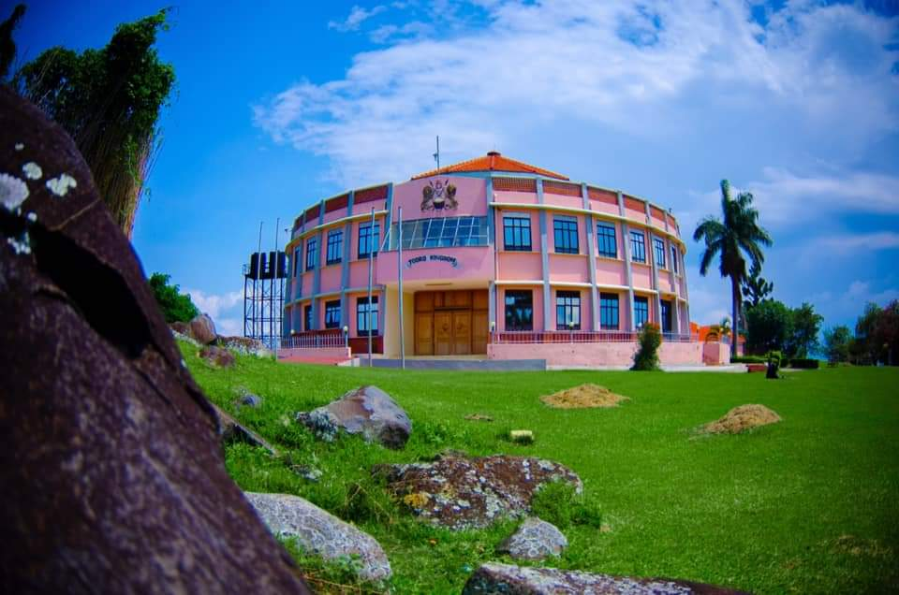

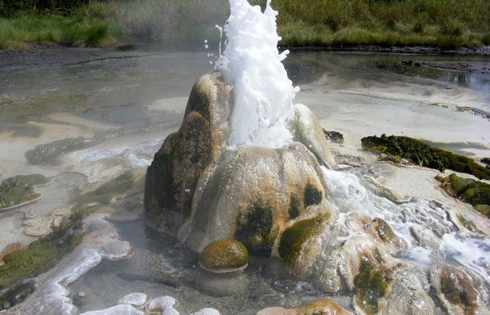

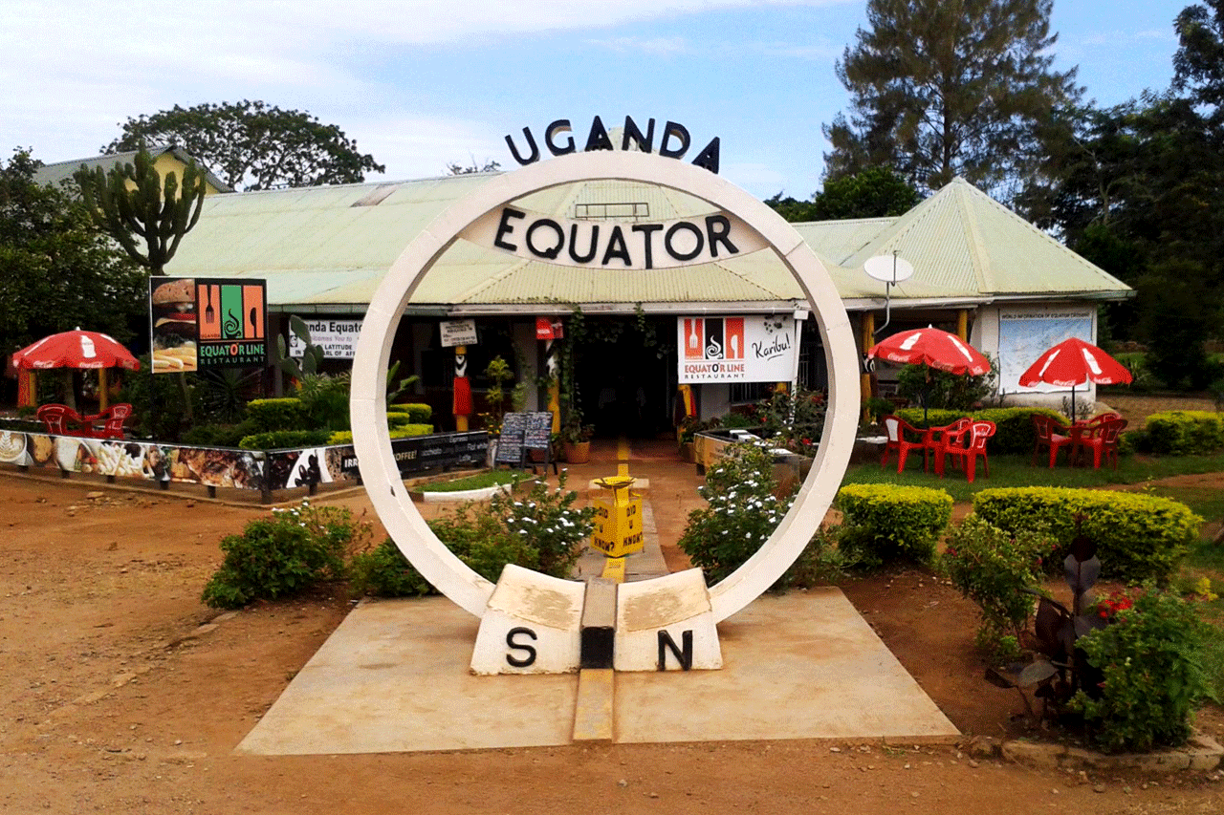

**Lake Mburo National Park Igongo Culture Center**

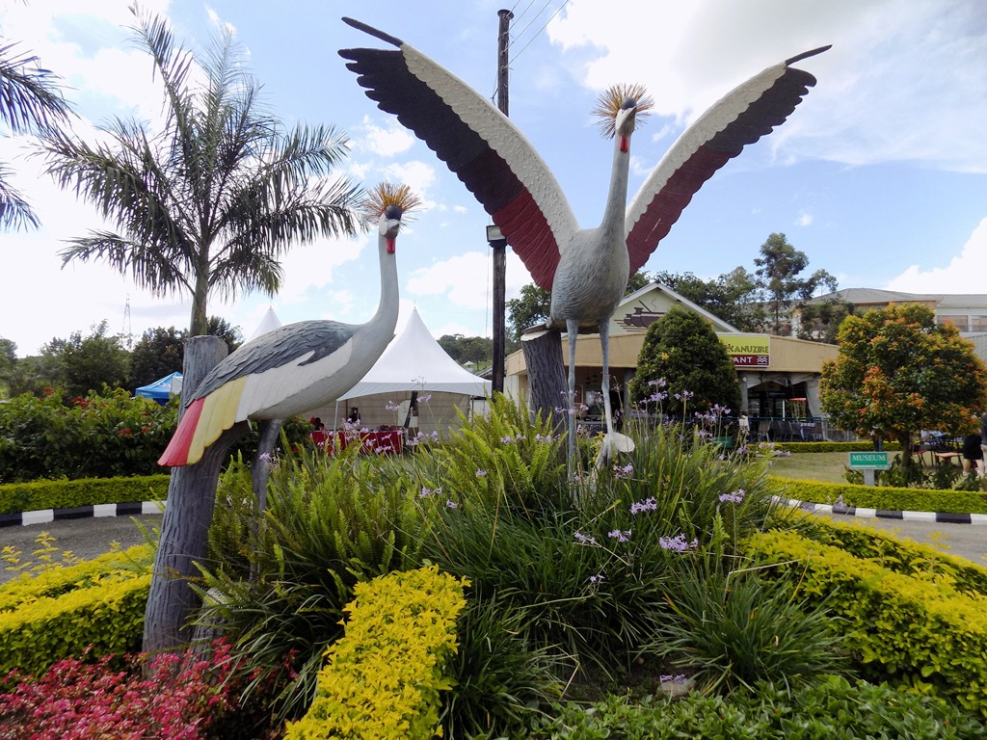

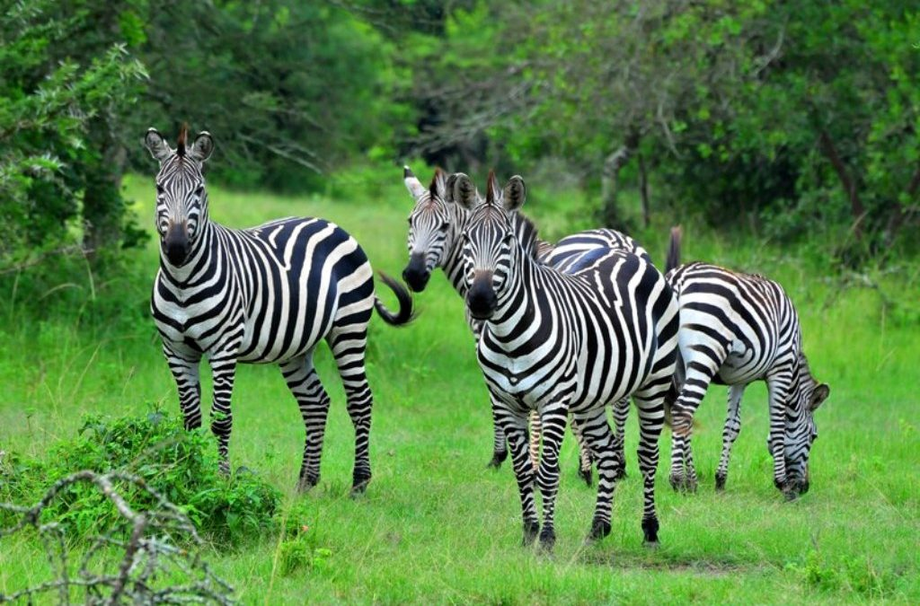

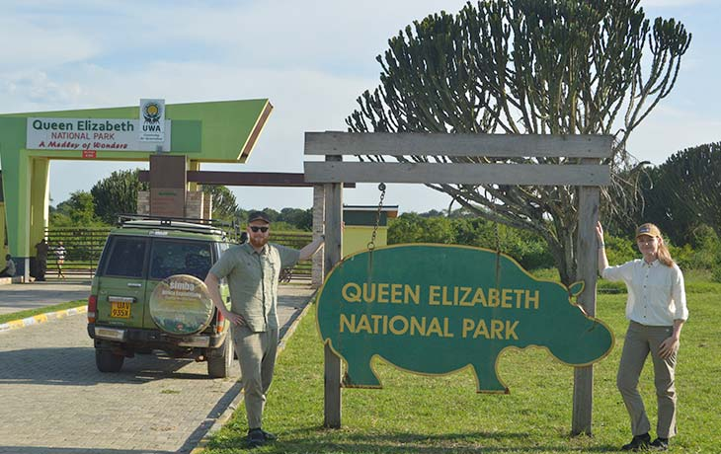

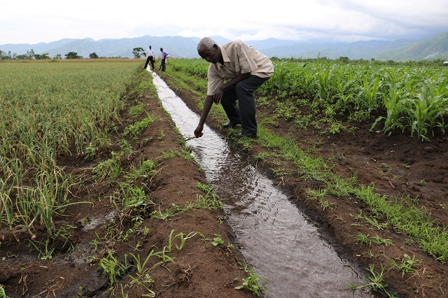

**Mubuku Irrigation Kazinga Channel**

